Product: Sorter Name web system

Description: this web system able to sort unsorted name to sorted name, it was developed using Microsoft asp.net core mvc technology.

Architecture: the architecture layer of this web system as screen capture below: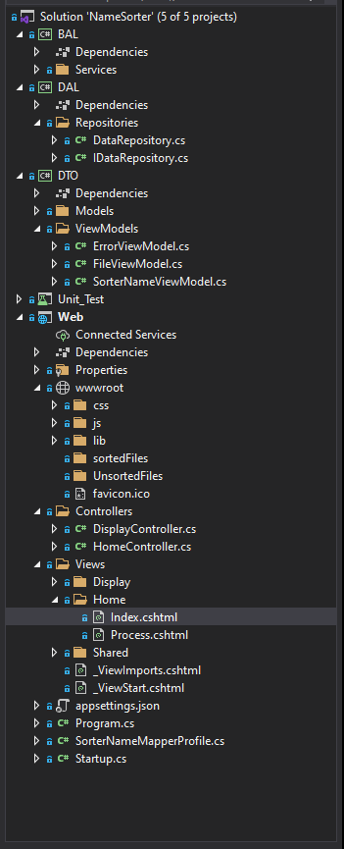

* BAL project

Is stand for Bussiness Access Layer which is in here All the logic will be exist (not on the controller side) which also here consist of many services

* DAL Project
* Is stand for Data Access Layer which consist of Repositories has 1 main job to read All data from file or database then will be process it inside of BAL Project
* DTO Project
* Is stand for Data Transport Object which only consist of models and view models class
* Web Project
* Is has one functionality to present things to the user

**Covering:**

1. The program only accept txt file as an input
2. All sorted name file will be put on sortedFiles folder or user can download it

**Running Program**

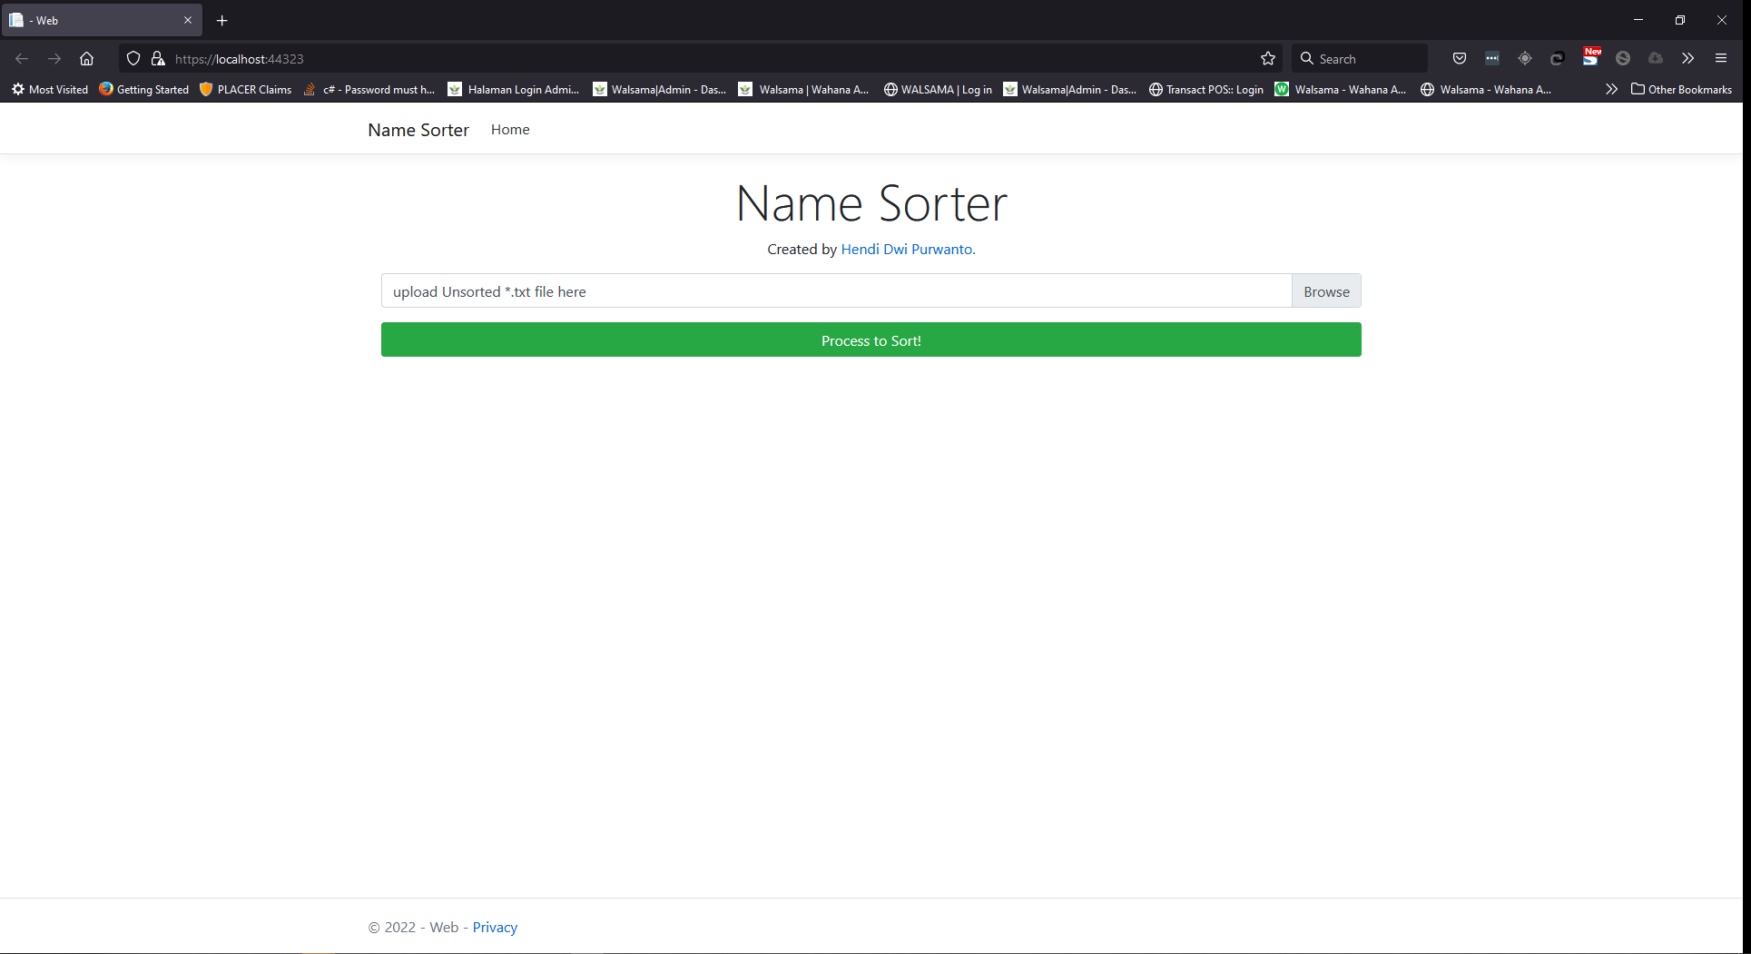

Above is look like if the program started

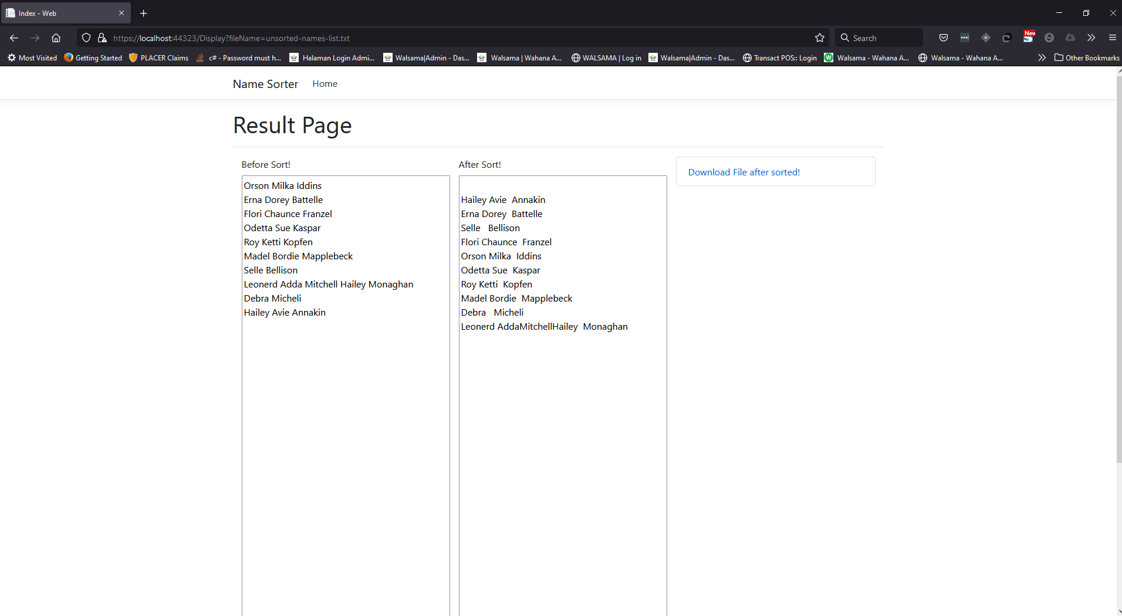

After process button clicked